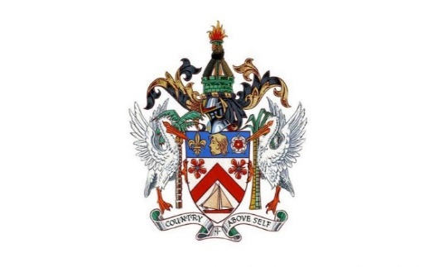

Government of St. Kitts and Nevis Ministry of Environment and Cooperatives
Department of Environment

CONSULTING SERVICES

COUNTRY: Saint Kitts and Nevis
NAME OF PROJECT: Enabling Activities for HFC phase-down in St. Kitts and Nevis
ASSIGNMENT TITLE: Updating the ODS Licensing and Quota System (LQS) in St. Kitts and Nevis.
PERIOD OF ASSIGNMENT/SERVICES: 3 MONTHS

BACKGROUND
The Montreal Protocol on Substances that Deplete the Ozone Layer is a well-established Multilateral Environmental Agreement (MEA). The Protocol has successfully prevented massive damage to human health and the environment from excessive UV rays from the sun by phasing out the production and consumption of substances that deplete the ozone layer. As a signatory to the Montreal Protocol, St. Kitts and Nevis is required to ratify the Kigali Amendment. The Kigali Amendment is an international agreement to gradually reduce the consumption and production of hydrofluorocarbons (HFCs) and entered into force on 1st January, 2019. Parties who ratify the Kigali Amendment, will be able to access technical, and financial support through the Multilateral Fund to facilitate strengthen of the legislative and policy framework, training of the National Ozone Unit (NOU), Customs and Enforcement Officers and Refrigeration and Air Condition (RAC) technicians. Parties who ratify the Amendment are also required to update their LQS to include HFCs. The Ministry of Environment and Cooperatives will be the Executing Agency for this project.

OBJECTIVE OF THE CONSULTANCY
The objective of this consultancy is to;
- To strengthen the existing regulatory import/export licensing system to include HFCs and HFC alternatives.

SCOPE OF SERVICES
The Consultant shall work under the guidance of the National Ozone Unit (NOU) along with a national expert or team from St. Kitts and Nevis.
The Consultant shall be responsible for:
  - Conducting a review of the current policies and legislation for the LQS
  - Identifying gaps and update of current LQS to include HFCs;
  - Reviewing and updating the data reporting systems;
  - Conducting an assessment of barriers and challenges in the implementation of the LQS

VENUE, OFFICE AND OTHER SUPPORT
The NOU will provide administrative support to the consultant including the organization of the sensitization workshop and coordinate relevant meetings and consultations.

REPORTING
The Consultant shall report to the National Ozone Unit (NOU) and may secondly, report to the Director of Environment. Note: The data compiled by the Consultant shall become the property of the Government of St. Kitts and Nevis.

DELIVERABLES
The International/National Firm or Group will be mainly responsible for the following deliverables:
  - A work plan, complete with timeline of deliverables, at the start of the consultancy;
  - Reports on (1) consultations with the NOU and (ii) key stakeholders
  - A report on the current policies and legislation for the LQS
  - An assessment report on the LQS to identify gaps, barriers, challenges, opportunities and recommendations to include HFCs and HFC blends in the LQS.
  - Report on reviewed and updated data reporting systems.
There should be
periodic reports/updates between the consultant and NOU after each
deliverable is met.

QUALIFICATION AND EXPERIENCE
The consultant must:
- Demonstrate exceptional analytical and quantitative skills, alongside strong synthesis and strategic thinking skills.
- Possess at least five years’ experience in the related field. Applicants with an Undergraduate degree with at least five years’ experience and at least three years’ experience working in the Montreal Protocol or any other related MEA will be considered.
- Demonstrate prior experience in identifying gaps.
- Prior related work experience in the region would pose as an advantage.
- Must have excellent written and oral English language skills;
- Demonstrate ability to work with a wide variety of people from government, non- governmental organizations.

LANGUAGE
All deliverables shall be written in English language.

REMUNERATION
The Consultant is required to submit a financial proposal, following which negotiations will be held with the successful applicant. In the assessment of submissions, consideration will be given to technical competence, qualifications and experience, regional experience on similar assignments, proposed cost and existing commitments.

SUBMISSION
Submissions must be made to the following address or by email by Thursday May20th, 2022 to:
Ms. Vicia Woods
National Ozone Officer
Department of Environment
Ministry of Environment and Cooperatives
3rd Floor Ursula Amory Building
Corner of Central and New Street Basseterre
St. Kitts
Tel: 1-869-466-8535
Email: vicia.woods@gov.kn
Cc: kelline.hendrickson@gmail.com

Any request for clarification must be sent in writing, or by standard electronic communication to the address or emails indicated above.

